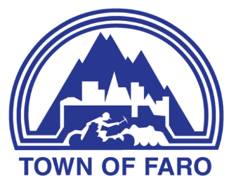
AGENDA
Regular Council Meeting
October 20, 2026, at 7:00 p.m.
Council Chambers

- CALL TO ORDER

- ROLL CALL

- DISCLOSURE OF PECUNIARY INTEREST

- DELEGATIONS AND PRESENTATIONS

- BUSINESS ARISING FROM DELEGATIONS AND PRESENTATIONS

- MINUTES
  - The review and passing of the Minutes of the previous Meeting.
    - Minutes of the October 6, 2026, Regular Meeting of Council

- REPORTS
  - Reports from Members of Council

  - Finance Report

  - Administrative Reports
    - Chief Administrative Officer
    - Manager of Operations
    - Manager of Recreation and Culture

- BYLAWS
  - 2026-06 – A Bylaw to Amend the Street Naming Bylaw No. 80-08 to Establish Road Names within the Town of Faro – First Reading

  - 2026-06 – A Bylaw to Amend the Street Naming Bylaw No. 80-08 to Establish Road Names within the Town of Faro – Second Reading

  - 2026-05 – Official Community Plan Bylaw – Second Reading

- MOTIONS / ITEMS FOR DIRECTION
  - Pecuniary Interest Matters

  - Arena Concession Lease Amendment

  - Snow Removal Policy

- PUBLIC QUESTION PERIOD

- IN-CAMERA MEETING
  - Draft Communications – in accordance with Municipal Act Section 213 (3)(e) re: Indigenous Protected and Conserved Area (IPCA)
  - Legal Matter – in accordance with Municipal Act Section 213 (3)(b&e) re: Pecuniary Interest Legal Opinion
  - Employment Matter – in accordance with Municipal Act Section 213 (3)(d) re: Employment Agreement

- IN-CAMERA MEETING REPORT

- ADJOURNMENT

