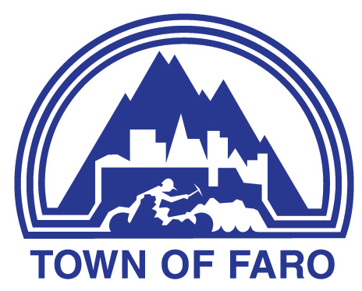
Agenda
Town of Faro Regular Council Meeting
May 5, 2026, at 7:00 p.m.
Council Chambers

- CALL TO ORDER

- ADOPTION OF AGENDA
  - Council Meeting Agenda

- DELEGATIONS & HEARINGS

- BUSINESS ARISING FROM DELEGATIONS & HEARINGS

- ADOPTION OF MINUTES
  - Minutes of the April 21, 2026, Special Meeting of Council
  - Minutes of the April 21, 2026, Regular Meeting of Council

- BUSINESS ARISING FROM MINUTES

- FINANCIAL
  - Finance Report

- REPORTS
  - Mayor’s Report
  - Council Reports
  - Administration’s Reports
    - Chief Administrative Officer
    - Manager of Operations
    - Manager of Recreation and Culture

- BYLAWS

- UNFINISHED BUSINESS

  - Proposed MOU Tintina Gun Club
  - Recreation Rules Policy

- NEW BUSINESS
  - 2026 Fee Schedule Amendments
  - Waste Disposal Site Fees

- CORRESPONDENCE FOR INFORMATION (OUT & IN)
  - Letter from Premier Currie Dixion, dated April 22, 2026, re: Ross River Protected Area Feasibility Study

- PUBLIC QUESTION PERIOD

- IN-CAMERA
  - Legal Matter - in accordance with Municipal Act Section 213 (3)(f) re: Legal Matter

- ADJOURNMENT

